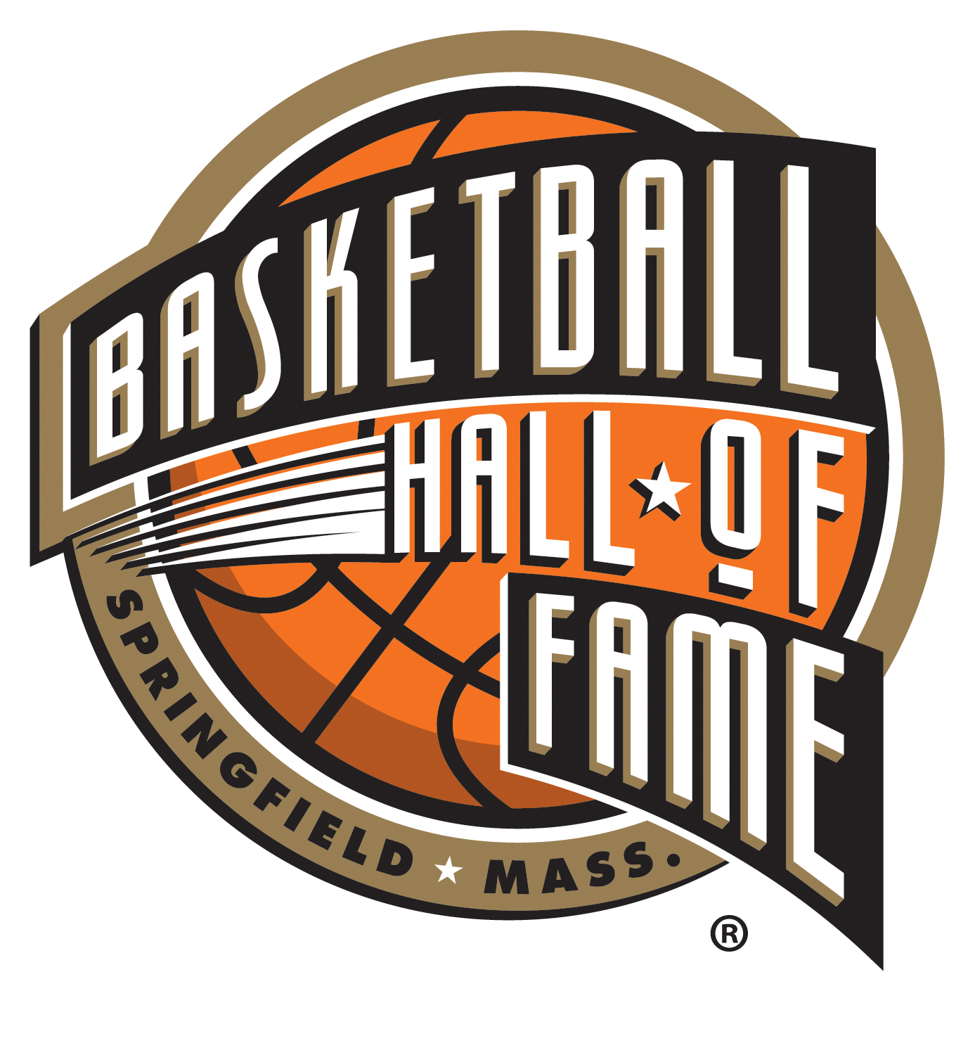

NAISMITH BASKETBALL HALL OF FAME ANNOUNCES WINNERS OF
2024 MORGAN WOOTTEN AWARD PRESENTED BY THE ELKS HOOP SHOOT
- Bob Farrell & Mike Kopp Honored as Outstanding High School Basketball Coaches -

SPRINGFIELD, MASS. (January 12, 2024) - The Naismith Basketball Hall of Fame announced the winners of the 2024 Morgan Wootten Award for Lifetime Achievement in Coaching High School Basketball:
- Boys - Bob Farrell, Seton Hall Prep (West Orange, N.J.)
- Girls - Mike Kopp, Allentown (Pa.) Central Catholic

The Elks Hoop Shoot presents the prestigious award named after Morgan Wootten, who dedicated 46 years as the Head Coach of DeMatha Catholic High School in Hyattsville, Maryland, and is one of four high school coaches enshrined in the Naismith Basketball Hall of Fame (Class of 2000). The annual award recognizes two outstanding high school coaches, one for boys’ basketball and one for girls’ basketball.

"Congratulations to Bob Farrell and Mike Kopp, recipients of the 2024 Morgan Wootten Award for Lifetime Achievement in Coaching High School Basketball,” said John L. Doleva, President and CEO of the Basketball Hall of Fame. “Their dedication and excellence in coaching embody the spirit of Morgan Wootten's legacy in the sport. Through their unwavering commitment, they have not only achieved success on the court but have also positively impacted the lives of their student-athletes. The profound influence these coaches have on their teams and communities reflects the true essence of the coaching profession, as they inspire and shape the future of the game and those who play it."

BOB FARRELL
Farrell went 777-169 (.821) in 34 seasons as head coach of Seton Hall Prep, highlighted by two New Jersey Tournament of Champions titles (1999 and 2005), 12 Non-Public A state championships, 10 Essex County Tournament crowns, and 26 conference championships. His 777 wins are the third most in New Jersey high school basketball history, trailing only Bob Hurley and Jerry Molloy, and Farrell was named Coach of the Year by the Newark-New Jersey Star-Ledger twice (1986 and ‘96). During his tenure with the Pirates, Farrell coached 31 players that played NCAA Division I basketball, including Brandin (Pittsburgh) and Brevin (Stanford) Knight, and Mike Malone (Loyola College), the current head coach of the 2022-23 NBA champion Denver Nuggets. He was inducted into the Seton Hall Prep Hall of Fame in 1993 and the Beach Ball Classic Hall of Fame in Myrtle Beach, S.C., in 2010.

MIKE KOPP
Kopp is the all-time winning coach in Pennsylvania high school basketball history, posting a 1,045-277 (.790) record in 46 seasons (1977-2022) at Attentown Central Catholic (1980-2022) and Notre Dame High School (1977-80), where his son, Josh, now coaches. Kopp led the Vikettes to five Pennsylvania Interscholastic Athletic Association (PIAA) titles, including becoming the first girls basketball program to win four consecutive Pennsylvania state championships (2001-04). Additionally, ACCHS won 18 conference championships and 21 district crowns, marked by 11 straight district titles from 2000-10. Kopp was inducted into the Lehigh Valley Basketball Hall of Fame in 2001, named the Associated Press Pennsylvania 3A Girls Basketball Coach of the Year in 2003 and 2004, and the 2014 National High School Coaches Association Girls Basketball Coach of the Year.

The Morgan Wootten Award winners were selected by a nationally based committee of Hall of Famers, national high school media members, tournament directors, and others who have significantly impacted the game. The 2024 Morgan Wootten Awards for Lifetime Achievement in Coaching High School Basketball will be presented during Hoophall Classic at Springfield College on Saturday, January 13, at halftime of the 7:00 PM game (Corona Centennial vs. Archbishop Wood). NOTE: Mike Kopp will not be in attendance.

MORGAN WOOTTEN AWARD WINNERS
YEAR  2007  2008  2009  2010  2011  2012  2013  2014  2015  2016  2017  2018  2019  2020  2024 | BOYS WINNER  Joseph Gallagher, St. John’s College HS  Jack Curran, Archbishop Molloy HS  Ralph Tasker, Hobbs HS  Robert Hughes, I.M. Terrell/Ft. Worth HS  Bob Hurley, St. Anthony’s HS  Ed Pepple, Mercer Island HS  Vito Montelli, St. Joseph HS  Gary McKnight, Mater Dei HS  Harvey Reid, Ralph L. Fike, HS  Bob Dwyer, Archbishop Carroll HS  William “Speedy” Morris, St. Joseph’s Prep  Gene Pingatore, St. Joseph’s HS  Bill Krueger, Clear Lake HS  Freddy Johnson, Greensboro Day School  Bob Farrell, Seton Hall Prep | GIRLS WINNER  Jim Smiddy, Bradley Central HS  Leta Andrews, Granbury HS  Dorothy Gaters, Marshall HS  Rick Insell, Shelbyville Central HS  Gene Klinge, West Central Community School  Brad Smith, Oregon City HS  Sandra Meadows, Duncanville HS  Thednall Hill, Hardy Highland HS  Joe Lombard, Canyon HS  Dr. Anthony Pappas, Waterloo West HS  Marcia Pinder, Dillard HS  John Hutchcraft, Guy Perkins HS  Frank Orlando, Detroit Country Day School  Jill Pruden, Oak Ridge HS  Mike Kopp, Notre Dame/Allentown Central Catholic HS

About the Elks Hoop Shoot Program
For nearly 50 years, the Elks Hoop Shoot has been developing gritty kids through a national free throw program for youth ages 8-13. For videos, news from the court, and more information about the Hoop Shoot, visit elks.org/hoopshoot.

About the Naismith Basketball Hall of Fame
Located in Springfield, Massachusetts, the city where basketball was born, the Naismith Basketball Hall of Fame is an independent non-profit 501(c)(3) organization dedicated to promoting, preserving, and celebrating the game of basketball at every level—men and women, amateur and professional players, coaches, and contributors—both domestically and internationally. The Hall of Fame museum is home to more than 400 inductees and over 40,000 square feet of basketball history. Nearly 200,000 people visit the Hall of Fame museum each year to learn about the game, experience the interactive exhibits, and test their skills on the Jerry Colangelo "Court of Dreams." Best known for its annual marquee Enshrinement Ceremony honoring the game’s elite, the Hall of Fame also operates over 70 high school and collegiate competitions annually throughout the country and abroad. For more information on the Basketball Hall of Fame organization, its museum and events, visit hoophall.com, follow @hoophall or call 1-877-4HOOPLA.

Basketball Hall of Fame Media Contact
Nicole Schuermann, Position Sports // mediarelations@positionsports.com

