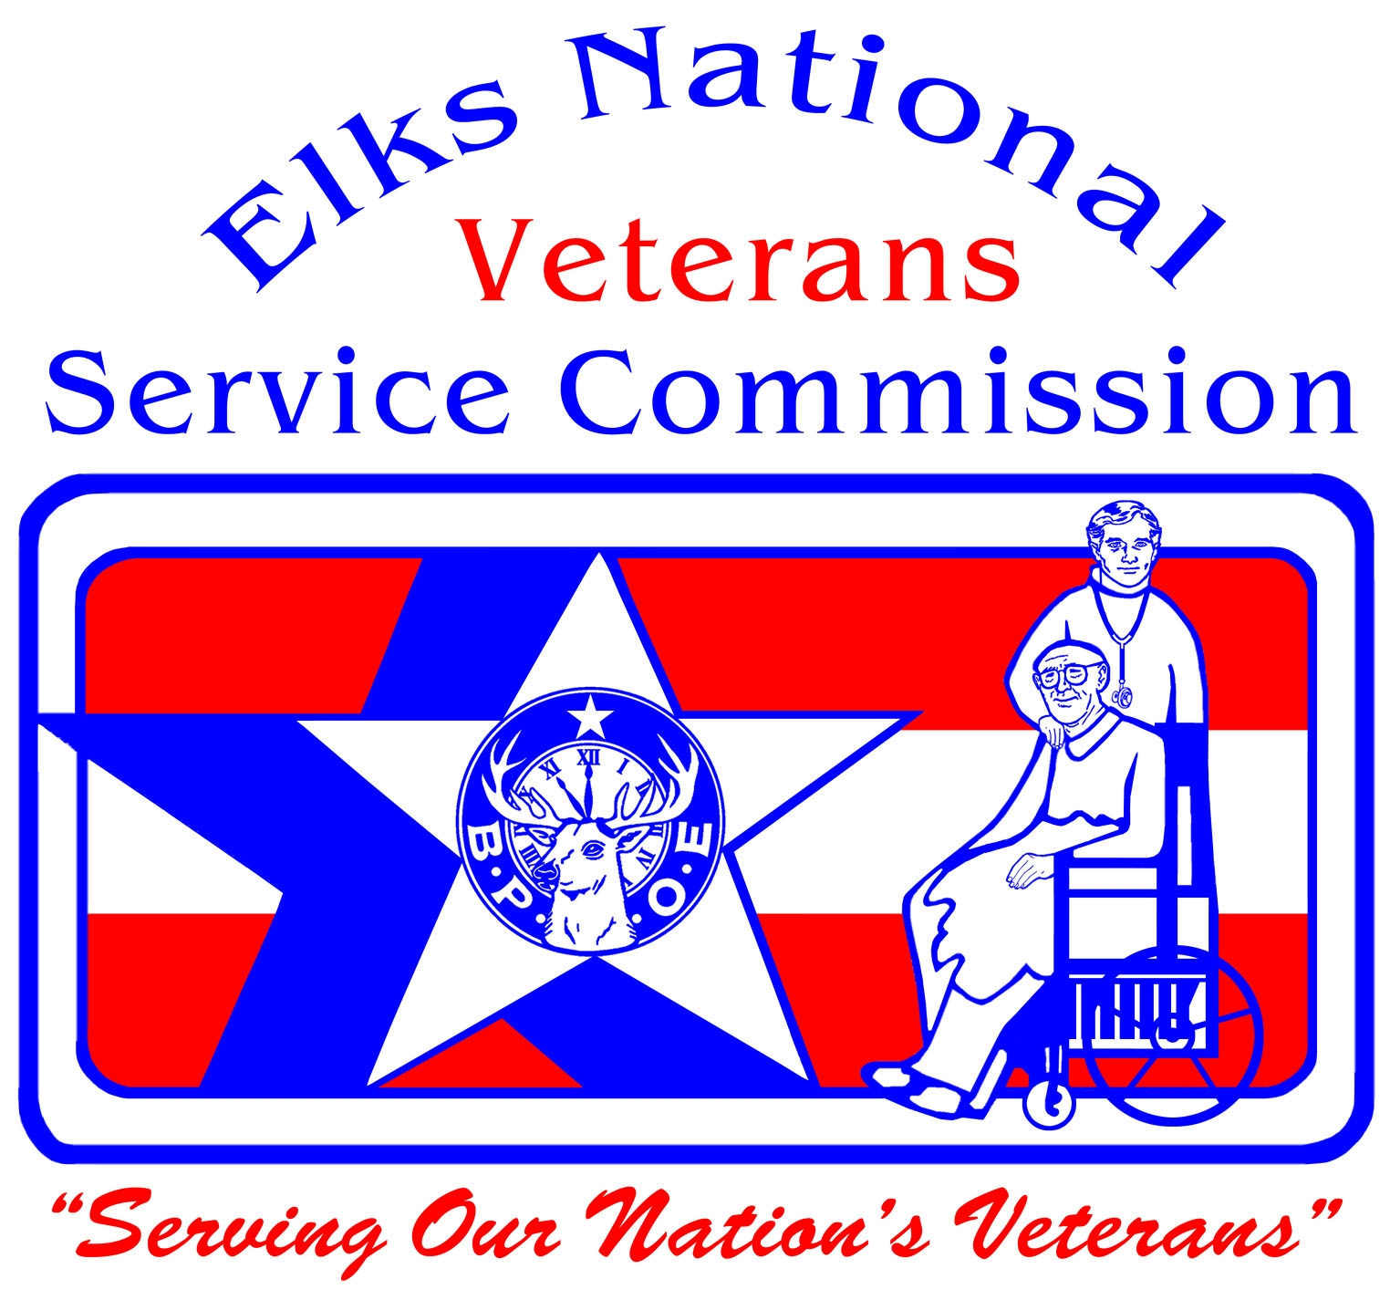 2011-2012 Freedom Grant Awards

New Orleans, LA (#30) will provide dinner for 240-275 homeless Veterans at the Lodge. The meal will be prepared and served by Lodge members.

Richmond, VA (#45) will take local Veterans on two bus trips to Washington, DC to the Vietnam Wall and the World War II Memorial and to a Washington Redskins Football Game. The Vietnam Wall and WW II Memorial trip will be scheduled in January and the football trip will be in October. Lodge members will accompany the Veterans on both of these trips.

Lima, OH (#54). In late Autumn, an Elk 'Santa Claus' will visit residents of their adopted VA Hospital in Dayton OH and get their wishes. Area youth will assist delivery of gifts and Christmas cards during the annual Christmas party at the hospital.

Mansfield, OH (#56). The Lodge will send care packages to Airmen serving in Afghanistan where their own Exalted Ruler is stationed. The Lodge will also provide household goods and school supplies for the troops’ children at home. In addition, the Lodge will collect and purchase items for transient Veterans in the community to help get them established.

Birmingham, AL (#79) will hold a Christmas party at a local shelter for homeless and needy Veterans. We will collect and purchase clothing, bedding, toiletries and other necessities for Veterans. We will also support more meals at the shelter throughout the year.

Seattle, WA (#92) will support Seattle’s first ‘Stand Down’ by providing 500-800 boxed lunches for homeless and ‘at risk’ Veterans and their families on September 15th. Over 50 Elks, family, and friends have volunteered to prepare the lunches. Lodge members experienced in Veterans affairs will also set up an office area at the Stand Down with computers, printers and scanners to help Veterans obtain needed forms to apply for benefits. We will also be assisting the VFW with any help they need in that area. We will distribute toiletries, socks, warm hats, gloves, disposable shavers, toothbrushes and toothpaste, combs and other items. We are assisting the Vet-Corps, Ameri-Corps, VFW and American Legion in this Stand Down.

Fort Worth, TX (#124) will support a musical therapy program for wounded Veterans. The Lodge will sponsor a program with the VA, set up as G4V chapter, with the Veterans' center in Forth Worth. This program will supply guitars, guitar lessons and music provided by a music therapist. This will be accomplished with donations from many different organizations such as the VFW, American Legion and the USO.

Galveston, TX (#126) Twelve to fifteen wounded troops from Texas VA facilities will be invited to participate in a weekend fishing tournament for the physically challenged, which will be held at the Galveston Yacht Basin. Elks will partner with the VA and Veteran's groups, local community agencies, and corporate donors.
Lafayette, IN (#143) will provide dinner for 75 Veterans including those from the local Veterans' home. There will also be expanded bingo and Christmas events at the Veterans’ nursing home.

Greenville, MS (#148) will provide dinner for 300 Veterans and guests. Lodge members will prepare and serve the meal. Local Boy Scouts will assist in serving and assisting the Veterans with seating and escorting as needed.

Lansing, MI (#196) The Lodge will host a Veterans Day dinner at the Veterans' homeless shelter. We will also have a Flag Day program with music, lunch and necessities for homeless Veterans.

Stockton, CA (#218) We will work with Palo Alto Veterans Hospital to supply household goods, funds and manpower to stock warehouse that services local Veterans' homeless shelters.

Ohio River Valley, OH (#231) The Lodge will ship boxes of comfort items to frontline soldiers serving in Afghanistan for the ‘Support Our Soldiers Now’ program. We will have Thanksgiving and Easter Dinners for local Veterans. We will give shoe vouchers to family members of locally adopted Veterans.

Middletown, OH (#257) will deliver complete Thanksgiving dinner baskets to needy families of troops serving overseas, working from a list provided by local recruiters. We will have a special ‘Honor Night’ dinner at the Lodge for all the local families of deployed solders.

Poughkeepsie, NY (#275) The Lodge will supply food and undergarments to 150 families of Veterans living outside the local VA. We will also provide necessities to VA patients inside the hospital and Christmas dinner for all Veterans at the Castle Point VA.

Walla Walla, WA (#287) The Lodge will host five dinners for members and families of the local National Guard unit. We will also help sponsor a dental van providing routine cleaning and exams for homeless Veterans between Sept. 1, 2011 and July 31, 2012.
Boise, ID (#310) The Lodge will Purchase 10-15 32" TVs for the Idaho State Veterans Home.

Las Vegas, NM (#408) Lodge will provide baby shower baskets (diapers, milk, clothing, etc.) for female Veterans returning from active duty. We will ship care packages to local units stationed in Qatar and Kosovo. The Lodge will also host appreciation dinners for Veterans in the community.

Winston-Salem, NC (#449) will provide Christmas gifts for Veterans at the Salisbury Nursing Home, a Veteran's day program and dinner, and a Christmas Party with ‘Santa’ and gifts for the families of local troops who are serving away from their families at that time. We will film the event and give the DVDs to the families.

Everett, WA (#479) will give Christmas stockings with fruit, candy, nuts and a gift for each of the 150 hospitalized Veterans at Seattle VA. Many of them have no family or visitors.

Belleville, IL (#481) will hold a lunch and dinner with entertainment for 200-300 service members and families of Scott Air Force Base. We will also bring gifts of toiletries, books, playing cards, etc., to the patients at Jefferson Barracks Hospital.

Miles City, MT (#537) will hold a Christmas Dinner at the Lodge for members and families of the local National Guard unit. We plan to adopt the unit and assist with starting a family support group. The Lodge will also have Thanksgiving dinner at Veterans Affairs Community Living Center.

Nevada, MO (#564) will hold a Christmas Dinner at the Lodge for the National Guard Unit with their families. There will also be a Veterans Day dinner for local Veterans including transportation for those that need it.

Derby, CT (#571) A program of delivering one year of pre-packaged frozen dinners to six Veterans in the community who are alone or shut-in. $30 buys ten meals for each Veteran once a month.

Santa Barbara, CA (#613) will work with local community organizations to provide homeless Veterans with gift cards for clothing, gas, and bus tokens. Our Lodge has a program called "Bring a Vet to Lunch" each month and we will use this grant to provide a Holiday event for the Veterans of our community.

Nashua, NH (#720). The Lodge will work with VASH , (Veterans Affairs Supportive Housing) to help homeless Veterans in shelters by purchasing warm clothing for them. We will collect and/or purchase cleaning supplies, cookware, can openers, toasters, dishes, bath towels, etc. for donation. Homeless Veterans are invited to the Elks Lodge for a monthly dinner, allowing them to ‘get out’ from their usual routine and socialize in a warm and hospitable setting.

Bessemer, AL (#721) will purchase and wrap Christmas gifts for the Veterans at the Birmingham VA Hospital. We will also host a Christmas party for Veterans in the Local Nursing home in the area. We plan to reach out to homebound and homeless Veterans in the community by working with local organizations.

Winfield, KS (#732) will purchase rehabilitation equipment and new beds for the Veterans Home in Winfield.

Wilson, NC (#840) will hold a Veterans Day dinner and P.O.W. ceremony for 96 Veterans with a Color Guard, music, and a special cake for WW II veterans. There will be a luncheon with transportation for 40 wounded Veterans and their families from Ft. Belvoir. We will also send care packages to Veterans at the new hospital in Kinston, NC.

Kaukauna, WI (#962) will provide coupon books for residents of the King Veteran's Home at King, Wisconsin. This is the only money they receive and is one of their biggest needs as identified by the King Home staff. Members will visit Veterans at King and distribute the coupon books. The Lodge will purchase fitness equipment for the King Veteran's Home at King, Wisconsin. We will also sponsor two Old Glory Honor Flights for World War Two Veterans from Northeast Wisconsin.

Rock Island, IL (#980) Lodge is teaming with a local television station to provide $100 per month for food for Veterans for one year. The Lodge will also have dinner for 100 local Veterans and the National Guard unit.
Rocky Mount, NC (#1038) will host 30 wounded soldiers (including family members) from the Wounded Warrior Battalion at Fort Bragg for a three day trip to Rocky Mount, including meals, entertainment, and transportation. Hotel rooms are also being donated.

Fayetteville, NC (#1081) will provide meals at the hospital and nursing home and gifts for Bingo. We will provide food and lodging for the all volunteer musical group Re-Creation. Last year, Re-Creation performed at 146 VA and state Veterans homes, entertaining 8,000 patients.

St. Petersburg, FL (#1224) The Lodge will supply tee shirts, underwear, socks, etc., to hand out at the Oct. 22 "Stand Down" event for homeless Veterans at Bay Pines Veterans Hospital. The Lodge will host a picnic for Bay Pine Veterans from the nursing home and domiciliary as well as a ‘USO’ show on October 1st.

Chicago Northshore, IL (#1316) will provide Thanksgiving gifts and dinner for 30 Veterans supported through our North District. Wii games for therapy and other items will be donated to Hines and North Chicago VA hospitals from hospital wish lists.

Alhambra/San Gabriel, CA (#1328) will give support to Fisher House which provides housing on hospital grounds for the families of troops undergoing medical treatment. The Lodge will provide year long support.

Catskill, NY (#1341) The Lodge will have breakfast for all local Veterans and their families. We will purchase presents, toiletries, clothing and large Christmas stockings for veterans in local nursing homes. Our members will also provide and distribute popcorn, ice cream, and coupon books to Veterans at the local hospital.

Martinsville, IN (#1349) will hold a Christmas Dinner for 200 members of local National Guard unit and their families with gifts for the children.

Las Vegas, NV (#1468) will host Thanksgiving and 'Christmas in July' dinners for area homeless Veterans. Comfort kits of clothing, items for personal hygiene, etc., will be included.

Orange, CA (#1475) will provide volunteer labor and purchase materials to repair and maintain 2 of 10 transitional houses for Veterans in Northern Californa. We will also provide home necessities and proper clothing for the Veterans to wear on job interviews.

Kelso/Longview, WA (#1482) The Lodge will host a dinner for over 100 Veterans of the local National Guard unit and their families. The Lodge will also provide assistance and information about Veterans benefits, including housing and family support. Entertainment and gift bags will be distributed at the dinner.

Ticonderoga, NY (#1494) The Lodge will have a dinner for local Veterans, and also supply information relating to Veterans benefits, the USO, etc.

Lowville, NY (#1605) will host a Lodge Veterans Appreciation Dinner for 350 local Veterans and active duty troops of the 10th Mt. Division and Veteran patients from Lewis County hospital. The Lodge will also deliver care packages for shut-ins who are unable to attend.

Hendersonville, NC (#1616) Domicile-provided buses will pick up the Veterans in Swannanoa and transport them to a Triple A baseball game with ball park food and beverages provided. They will be seated in a special section of the park and greeted by members of the "Tourists". After the game, transportation will be provided for the Veterans to attend a dinner of steak, baked potato, vegetable and salad at the Hendersonville Elks Lodge.

Sanford, NC (#1679) The Lodge will sponsor a Veterans Breakfast for local Veterans and a cookout including entertainment at the Veterans nursing home. We will also send care packages to the troops for Christmas.

Auburn, CA (#1691) will provide dinners (hospital approved menus) in November for 80 Veterans in the Reno, Nevada Veterans Hospital. The Lodge will also provide toiletries, phone cards, and other gifts for the Veterans. In March, the Lodge will host a family style dinner for 150 Veterans at the Lodge and a BBQ at the VA Hospital.

Shelby, NC (#1709) will host a free monthly dinner at the Lodge featuring our Western NC Bar-b-Que for the local Veterans. We will have a special all day dinner on Flag Day hosting 40-50 Veterans.

Onancock, VA (#1766) will host a dinner, Bingo, and gifts for 227 local Veterans living in rural area with little to do and little family contact.

Plymouth, MI (#1780) The Lodge will have Steak Luncheons in November and April. We will serve Veterans from the Detroit and Ann Arbor VA hospitals, as well as Homeless Veterans from a Veteran homeless shelter in Detroit. We will also have Chili Dog luncheons at the Detroit VA in October and April. The Masons, American Legion, and Knights of Columbus will support the event with help in serving the meals.

Cartersville, GA (#1969) will assist returning Veterans with disabilities by teaming up with US Army Wounded Warrior Program of Northern GA. We will also provide Christmas baskets of food, clothing, blankets and whatever is needed to the families of these same Veterans.

Kerrville, TX (#2081) plans to host a hunting trip for 2-4 Veterans who are in the South Texas VA Hospital system, either living at one of the VA Hospitals or being treated as outpatients. This trip will be all expenses paid including hunt, ammo, travel, food, lodging and processing of animals. The processed meat will be given to the Veterans and their families.

Clayton, NJ (#2132) will host a dinner at the Lodge for 50 Veterans from a local Veterans home. Entertainment and gifts will be provided.
Wheaton, IL (#2258) will supply gifts for Veterans at the Hines VA Hospital. We also plan to purchase computers and furnishings for the Midwest Shelter for Homeless Vets.
Clear Lake (Kemah), TX (#2322) will host a hunting trip for 5- 6 Veterans from Brooks Army Medical Center in San Antonio, Texas. Hunt will include all necessary hunting equipment to hunt deer, hogs, birds and pond fishing. All meals and accommodations will be included. The Lodge will also assist in the Houston VA Stand Down on October 20th for homeless Veterans, by providing two meals in one day for 500 Veterans and volunteers. The Lodge, along with the city of Kemah, TX, will host a dinner for 100 Wounded Warriors and their families on November 3, 2011.
Arcadia Valley(Arcadia), MO (#2330) will use $1,000 to purchase clothing for Christmas gifts for the VA Home in Jackson, MO. $500 will go towards a Veterans Thanksgiving dinner and donation to Camp Hope, which brings disabled Veterans to a camp setting.

Kern River Valley, CA (#2358) will send 100 care packages to troops in Afghanistan.
Oak Harbor, WA (#2362). The Lodge will have three events for military personnel stationed at nearby Whitby Island. Events will include a dinner, a luncheon with entertainment at the Lodge, and a Christmas visit to the base with presents for those unable to leave the base.

Vernal, UT (#2375) The Lodge will provide personalized blankets for patients in VA and contribute to the purchase of four blanket warming machines.
Lake Havasu City, AZ (#2399). The Lodge will sponsor two Honor Flights for WW II Veterans to see the WW II Memorial in Washington D.C, and Christmas gifts for Veterans at Prescott VA Hospital.

Poplar Bluff, MO (#2452). The Lodge will increase frequency of coffee and doughnuts provided at John J. Pershing VA Hospital from one to two Saturdays per month. We will give Christmas gifts to patients at the VA Hospital. The Lodge will host recognition dinners for Veterans from the VA hospital, with introductions and special treatment. The Lodge will also make a donation to the USO.

Edison, NJ (#2487) will hold holiday parties at two local Veterans homes: Menlo Park State Veterans Home and the Lyons VA Hospital.

Lake Taneycomo, MO (#2597) will have a breakfast for 120 Veterans and give Christmas presents to all of the veterans in the the Veterans Home, and create care packages for troops overseas.

Orange Park, FL (#2605). The Lodge will supply bottled water for one year to the USO at the Jacksonville, FL Welcome Center.

Katy, TX (#2628) will hold a Veterans Day Dinner for residents of Veterans nursing home. Baseball caps, food, clothing, and lap robes will be given to residents.

Eureka-Pacific, MO (#2644) will host two all day events at the Lodge with food, Bingo, music, games and a display of military vehicles and other military related items. Veterans will arrive in buses from Jefferson National Barracks.

Jackson, MO (#2652). The Lodge will partner with Perryville, MO Lodge # 2701 for a BBQ at the Veterans Home. There will also be a Lodge dinner featuring a DJ and raffle for local active duty National Guard and reserves to honor Veterans and three fallen heroes. A small part of the Freedom Grant will be used to buy wreaths for Veterans' graves as part of the Wreaths Across America program.
Novato, CA (#2655) will hold a Veterans Day On the Bay fishing trip. We will provide Veterans from the Yountville Veterans Home as well as local active duty personnel and their families with a chance to enjoy the great outdoors. We will be partnering with the Boy Scouts of America and Air Force ROTC.

Calabash, NC (#2679). The Lodge will put on a Valentine’s Day Lunch at the VA Hospital in Fayetteville, NC and a Barbecue at the VA Home in Fayetteville. The Lodge will also make a donation to food locker and purchase Christmas gifts for local military at Beaufort MCAS and Parris Island. We will also have a Thanksgiving lunch at Fayetteville VA and will support a ‘Welcome Home’ celebration for returning troops.

Marion County, AL (#2684). The Lodge will have a Veterans Day picnic for two area nursing homes, and a Veterans Day banquet at Lodge. We will also purchase and deliver care packages for the Veterans in the nursing homes.

Santee, CA (#2698) will host one dozen Veterans from the VA hospital to be our guests for the entire day of Thanksgiving including gifts of toiletries, snacks, reading material, and phone cards. The Freedom Grant will also be used to help pay for postage of care packages sent overseas. We are planning an outreach to military spouses and families by inviting them to monthly Lodge luncheons with speakers from military support groups.

Golden, CO (#2740). Lodge members will volunteer at a Stand Down for homeless Veterans and donate $2,000 for clothing, shoes, and other necessities.

Tri-Cities, WA (#2755) will be working with the Columbia Basin Veterans Coalition (CBVC). Our Lodge will use the grant to purchase a freezer, range hood, and other items for the Veterans transitional housing unit. Lodge members and other volunteers will deliver and install appliances, celebrating the event with a ‘Christening Party’ for the residents.

Pahrump, NV (#2796). The Lodge will send Christmas care packages to the military in Afghanistan and Iraq, and give Christmas and Valentine’s Day gifts to the Veterans in our local Veterans nursing home.

Little River, SC (#2840) will purchase 20 tickets for Veterans at an assisted living facility to attend a Christmas Show. $1500 will be used to provide transportation, food, and essential items needed by area Veterans. We will work with the DAV (Disabled American Veterans) Program to provide vouchers to needy local Veterans. The vouchers can be used only to purchase food and other essential items at the local Food Lion.

Sahuarita, AZ (#2851) will have a party for the Veterans at the Tucson VA Blind Rehab Unit and give them gifts of lap robes, warm shirts, jackets, and other in demand items.

