Name:
Title:
Lodge name and number:
Address:

Telephone:
Email:
Photo | Item Name | Price | Quantity*
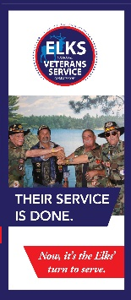 | ENVSC Brochure | No Charge
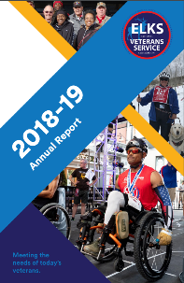 | ENVSC Annual Report | No Charge
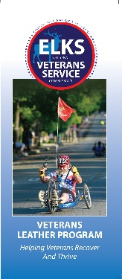 | Leather Program Brochure | No Charge
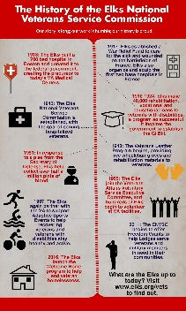 | Elks Veterans History Timeline | No Charge
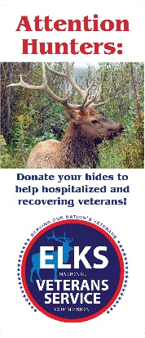 | Hunters Donate Your Hides Brochure | No Charge
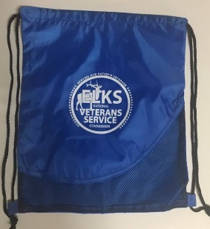 | Elks Veterans Service Drawstring Bag | 4.00
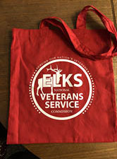 | Elks Veterans Service Canvas Bag | 4.00
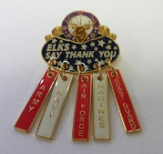 | Elks Say Thank You-Armed Forces Pin | 7.00
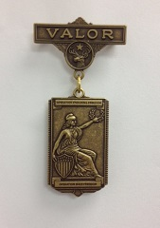 | Medal of Valor | 8.00
*Order quantities may be limited depending on available stock.

