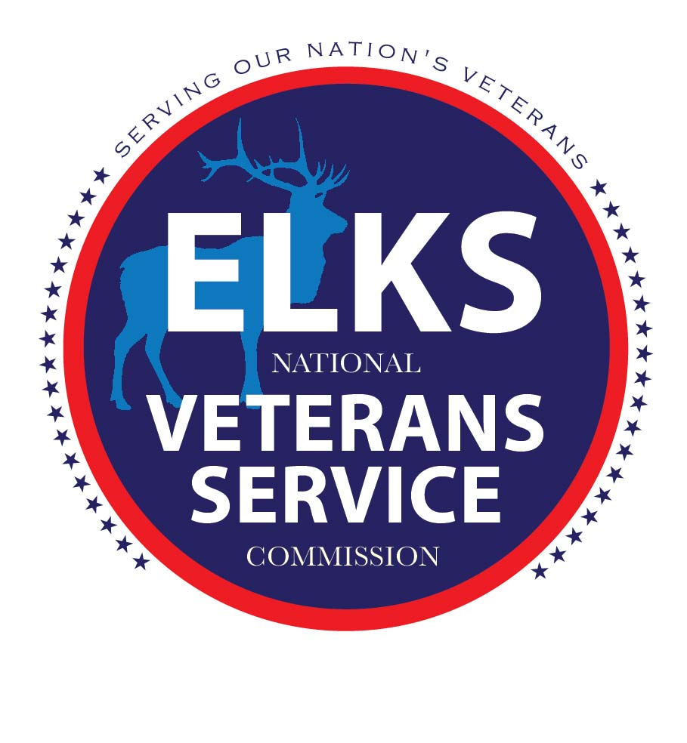
CONSENT TO PHOTOGRAPH
CONSENT TO RELEASE INFORMATION
I, __________________________________, give my permission to use and reproduce: (print name)
audio print video photo
photograph other __________________
for any and all purposes reasonably related to the conduct and promotion of the Elks Lodge and/or the Elks National Veterans Service Commission. I understand that all materials will remain the property of the Elks Lodge and/or the Elks National Veterans Service Commission and I am not entitled to any compensation or payment for their use.
Date: ___________________________________________________________
Signature: _____________________________________________________ (parent/guardian signature required for minor)

