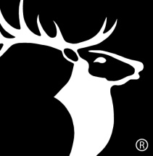
An Impact on Elks Communities

What would your Lodge do with $10,000 to serve your community? With Elks National Foundation Impact Grants, the possibilities are endless. Using 2012 Community Investments Program Impact Grants, Lodges across the country have done big things to help their communities.

Consider Coos Bay, Ore., Lodge No. 1160, which used an Impact Grant to help local youth. Each week, the Coos Bay Elks purchase and pack more than 700 backpacks full of weekend meals for children in need.

“The community has embraced the project and the work that the Elks do,” says Project Manager Sharon Kolkhurst. “And we are taking pride in being Elks.”

That’s just one example of the many accomplishments of Impact Grant recipients. ENF Impact Grants are competitive grants ranging from $2,500 to $10,000 to fund a charitable project. Impact Grants help Lodges address unmet needs in Elks communities. View the complete list of 2012 Impact Grant accomplishments at www.elks.org/enf/community/ImpactGrants.cfm.

